Posterolateral corpectomy with pyramesh titanium cage reconstruction in dorsolumber Metastatic lesions
Ahmed Kamal Abdelhameid, Ahmed Saro, Khaled Nasser Fadle
Neurosurgery department, Sohag faculty of medicine
Abstract
Background data: The vertebral column represents the most common bony site for metastasis with an incidence ranged from 30% to 70% in patients with metastatic neoplasms. The dorsal spine carries the highest frequent site for metastasis all over the vertebral column followed by the lumber spine. These metastatic lesions are clinical entities that often necessitate a complex spinal decompression and anterior reconstruction. Posterolateral approaches alone allow for excellent decompression with transpedicular fixation and safe visualization of the neural elements for corpectomy and reconstruction so we can avoid the complications that can be happened with the staged surgery.
Purpose: our aim in the study is to report cases and evaluate our approach for fixation and assess the postoperative period regarding pain improvement and neurological deficit.
Study design: A retrospective study included 26 patients presented to neurosurgery department at Sohag university hospital within three years, between August 2014 and August 2017. Evaluation made through using the Quebec Back Pain Disability Scale and muscle power grading scale.
Material and methods: Twenty-six patients with metastatic dorsolumber spine lesions underwent a single-stage surgery by midline posterior approach. Posterior decompression with transpedicular fixation above and below the affected segment was done for all patients. Unilateral facetectomies and pediculectomy followed by corpectomy was done. Insertion of pyramesh titanium cage filled with iliac bone graft with tightness of the screws bilateral. Follow up period was 6-12 months postoperatively.
Results: The average age was 58.36±5.96 (range 33-67) years. More than two thirds of them were males (69.2%). Majority of the lesions were dorsal (77%). Postoperative infection observed in four patients (15.4%) who improved by IV antibiotics and frequent dressing while CSF leak occurred in three patients (11.5%) who stopped after daily dressing and we made CSF lumbar tap in one patient. Twenty-two patients showed neurological improvement post-operatively (84.6%). The remaining four were paraplegic with no improvement. Back pain improved for all cases.
Conclusion: Posterolateral approach alone is an efficient safe for dorsolumber decompression and reconstruction in metastatic spine.
Keywords: Corpectomy – Pyramesh - posterolateral - pediculectomy- facetectomies.
Introduction
The vertebral column metastasis can contributes for about 30-70 % of metastatic lesions in metastatic neoplasm patients so it is the most common site for bony metastases. ^{3,5,26} Presence of the dural matter as a relative barrier for the spinal cord as 98% of spinal metastasis are extradural lesions.⁷
The dorsolumber spine is the frequent site for metastasis and more than the cervical region and lesions in this site are often need a complex spinal decompression and reconstruction. ^{8,11,15} Traditionally, the dorsolumber metastatic lesions surgeries necessitate combined approach or staged anterior and posterior decompression and fusion. ^{17,21,24}
Anterior approach carried the advantage of excellent visualization of the vertebral body and pathological condition; however the possibilities of iatrogenic morbidity especially in critical ill patients make it to a risky approach. ² Posterolateral approaches appeared to have excellent way for posterior decompression with transpedicular screws fixation and in the same time allows for safe visualization of the neural elements with corpectomy and placement of mesh cage. ^{11,18,20,24}
Our study goal is to report a clinical series of 26 patients in Sohag university hospital with dorsolumbar metastatic lesions from different primaries treated by single-stage posterolateral circumferential corpectomy with reconstruction by a pyramesh titanium cage and account the degree of improvement regarding the pain.
Patients & Methods
At neurosurgery department in Sohag faculty of medicine, Between August 2014 and August 2017, 26 patients with single dorsolumbar metastatic spinal lesions with vertebral body collapse underwent a single-stage, circumferential corpectomy and anterior spinal reconstruction with a pyramesh titanium cage via a midline, posterior, lateral approach.
We included in our study patients with retropulsed fragment inside the canal that causes spinal cord compression with neurological manifestation. Metastatic work up was done for our cases. Exclusion criteria include patients with more than one spinal metastases or extra-spinal metastasis, patients with other comorbidities as cardiac ill patients, patients with chronic renal failure and patients who received radiotherapy or chemotherapy within one year before surgery. A preoperative neurological assessment, full laboratory investigations and medical were done. We used the Quebec scale to assess the patients’ improvement regarding pain (Fig 1), and muscle power scale to evaluate the motor power improvement (table 1)
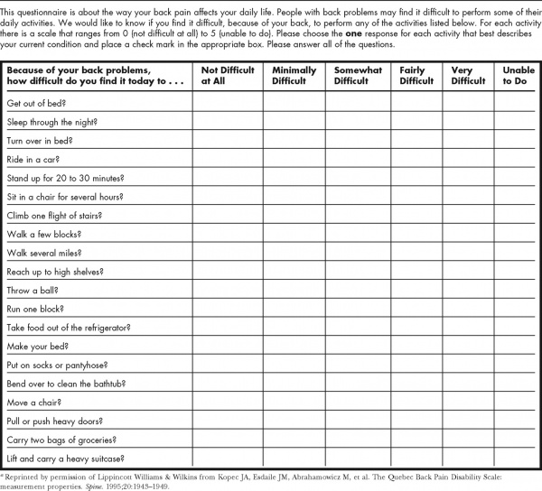
Fig 1. Quebec Scale ¹²

Table 1. Muscle power grading ¹
Grade | Meaning
0 | Complete paralysis
1 | Flickering
2 | Movement with elimination of gravity
3 | Movement against gravity
4 | Movement with some resistance
5 | Normal power

Operative Technique
Under general anesthesia with hypotensive anesthesia technique our patients were placed prone in radiolucent spine frame that allows for intraoperative AP and lateral imaging by C-arm. A standard midline posterior skin incision is done with subperiosteal dissection above and below the affected level. Cauterization was done for the bleeding points.
In the majority of our cases transpedicular screws are placed bilaterally two levels above and two levels below the involved vertebra. However in one case we noticed a high level of wedged vertebrae with osteoporotic bone so we lengthened the fixation levels in this patient. A rod is placed unilaterally contralateral to the side planed for pediculectomy and corpectomy and gentle distraction is applied for stabilization of the spine during the manipulation for corpectomy Fig (2).
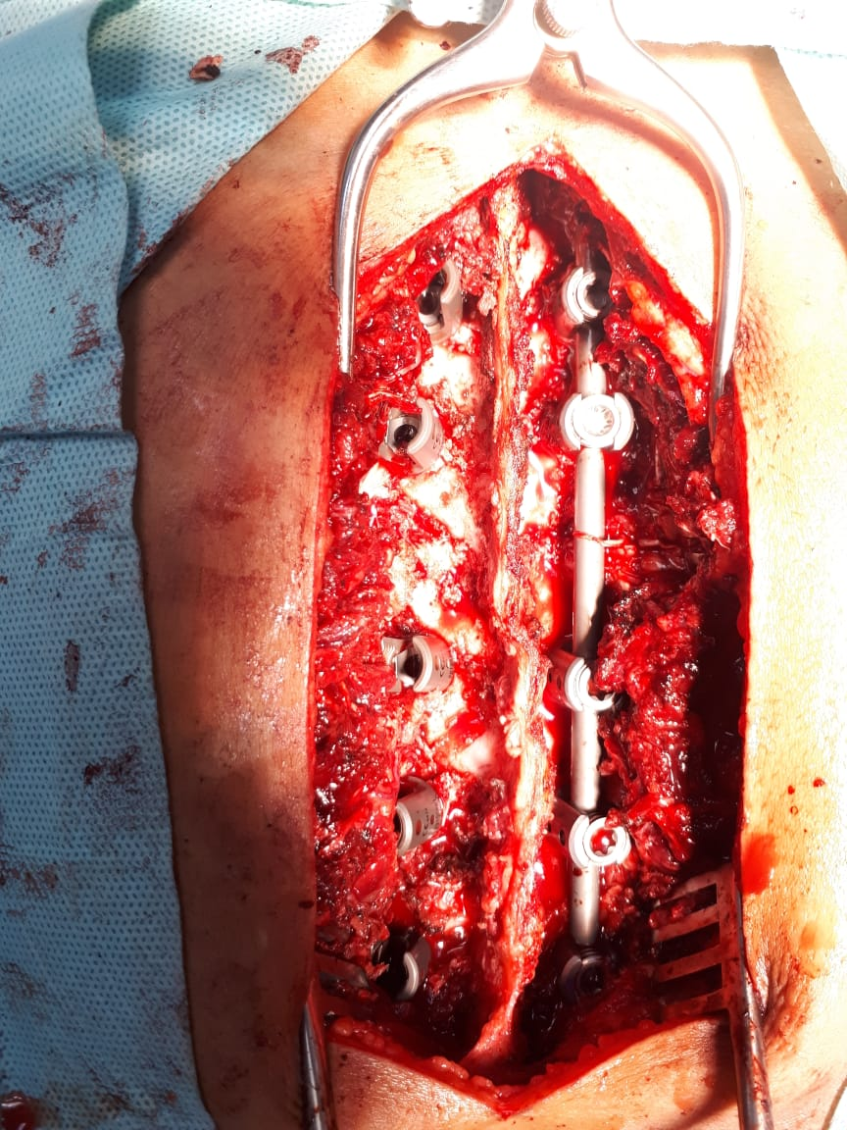
Fig 2. Placement of the rod on one side with distraction
At the affected vertebrae laminectomy is carried out with removal of the facet then skeletonizing pedicle. Only laminectomy with facetectomies can be done in one level above and below the affected vertebra to maximize the cephalic caudal working space between the nerve roots, which becomes critical during the pyramesh cage placement. At the dorsal spine lesions we can sacrifice with the nerve root by ligation and bipolar cauterization to decrease the possibility of CSF leak.
At the aimed level, the transverse process is resected using a kerrison rongeur then exposing the lateral edge of the vertebral body. In the dorsal spine disarticulation of the transverse from the ribs should be done first. Subperiosteal dissection is performed using the cobb. Packing sponge applied very gently and slowly around the vertebral body to avoid the potential vascular, pleural or peritoneal injury. A high-speed burr is then used cautiously to drill the pedicle and the vertebral body away from the exiting nerve root and the spinal cord Fig (3).
Curettes were used to perform the discectomy above and below the involved vertebrae. If the vertebral body was completely destructed we went for bilateral corpectomy but if the lesion was unilateral we performed a unilateral pediculectomy, discectomies, and corpectomy till the creation of an egg shell hole leaving the other side that augments the posterolateral fusion bed. Dorsal cortex should be preserved to minimize the epidural bleeding and protection of the spinal cord. Once the discectomies are completed, the vertebral body is hollowed using the high speed burr and curved curettes.
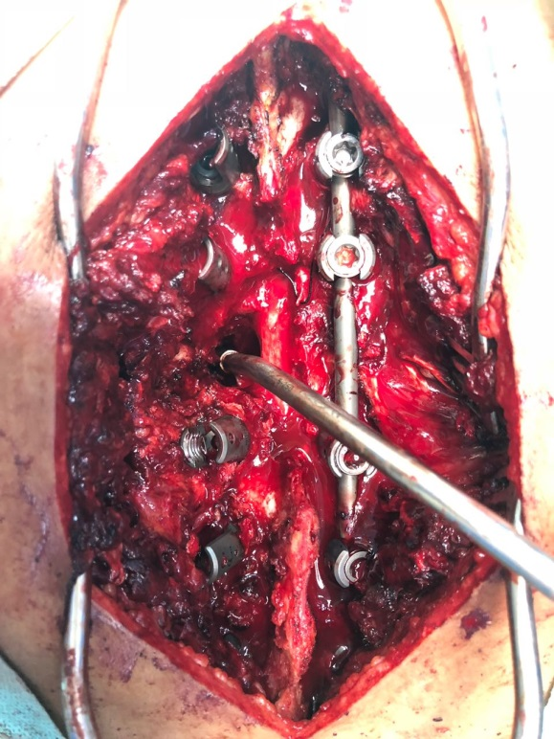
Fig 3. Laminectomy followed by corpectomy in one side
The most challenging part of the procedure occurs with the pyramesh cage placement. Firstly we measure the length of the suitable cage and filled with iliac crest bone graft.
Placement of the cage should be parallel to the nerve root with gently retraction of the root. Once we entered the cage inside the corpectomy hole we rotate it 90º until it is perpendicular to the adjacent vertebral endplates Fig (4).
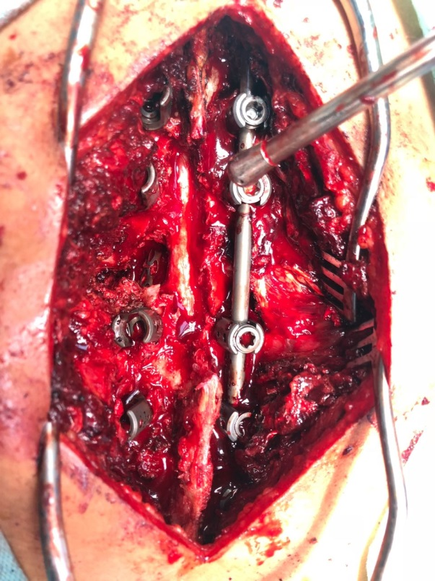
Fig 4. Placement of the titanium pyramesh
Distraction was then performed under direct fluoroscopy with very gently modulation of the cage to reach its appropriate position against the vertebral endplates without tilting, Fig (4).
Finally, we placed the second rod with loosening of the first rod screws to make bilateral compression across the affected segments. All of the set screws were tightened and additional bone graft was then packed around the posterolateral contralateral side.
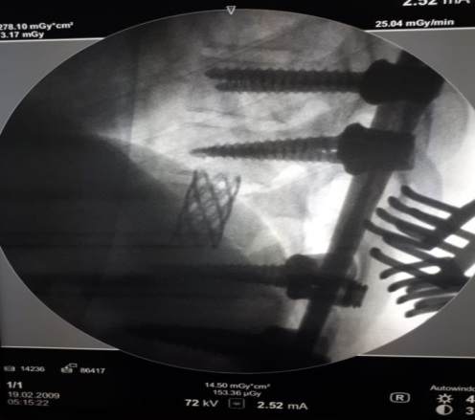
Fig 5. Intraoperative fluoroscopy showing the placement of the pyramesh
Statistical analysis
Data was analyzed using Microsoft Excel 2016 (Microsoft corporation, USA) and SPSS version 24 (May 2016, IBM corporation, USA). Qualitative data was presented as numbers and percentages; while quantitative data were presented as mean and standard deviation. Comparison between pre and postoperative data regarding Quebec scale and motor power was done using paired t test. P value of less than 0.05 was considered as significant.
Results
Twenty six patients with metastatic dorsolumber lesions with predominance of male ratio table (2).
Table 2. Gender distribution
Male | 18 patients | 69.2%
Female | 8 patients | 30.8%
Our patient's age ranged from 33-67 years with a mean of 58.36±5.96 years. In our study the dorsal metastatic lesions were more predominant that account for 20 cases. On the other hand the lumber metastatic lesions were only 6 cases (table 3).
Table 3. Metastasis location
Site | Number of cases | Percentage
Dorsal | 20 cases | 77%
Lumber | 6 cases | 23%
Metastasis of unknown origin was reported in 10 patients, breast cancer was responsible for 8 cases, four cases with prostatic cancer, three cases with small cell lung cancer and the last case was with retroperitoneal sarcoma (Fig. 6).
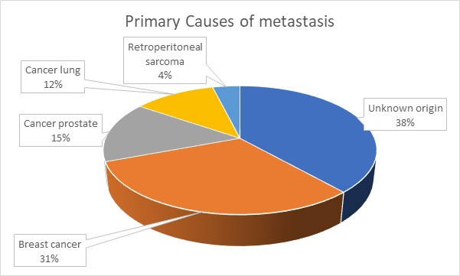
Figure 6. Origin of metastasis
Back pain was the main complaint for all our patients and we use the Quebec Back Pain Disability Scale for pre and post-operative assessment (table 4 and Fig. 7).
Table 4. Improvement regarding pain using Quebec scale
Pre-operative |  | Post-operative
Quebec scale | No. of patients | Quebec scale | No. of patients
98 | 6 | 72 | 6
86 | 8 | 40 | 9
60 | 5 | 35 | 5
25 | 7 | 15 | 6
Paired t test = 8.742, p value <0.001 (highly significant)

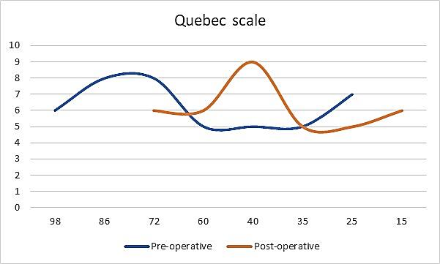
Fig 7. Improvement regarding pain using Quebec scale

Six patients were paraplegic grade zero more than 10 days preoperative. Improvement in the motor power occurred in two of them while the remaining four did not improve but the sensation regain and the back pain improved (table 5 and Fig. 8).
Table 5. Preoperative muscle power state
Pre-operative |  | Post-operative
Motor power | No. | Motor power | No.
Complete paraplegia | 6 | Complete paraplegia | 4
Grade I | 7 | Grade I | 0
Grade II | 2 | Grade II | 0
Grade III | 5 | Grade III | 3
Grade IV | 6 | Grade IV | 10
Grade V | 0 | Grade V | 9
Paired t test = 7.939, p value <0.001 (highly significant)

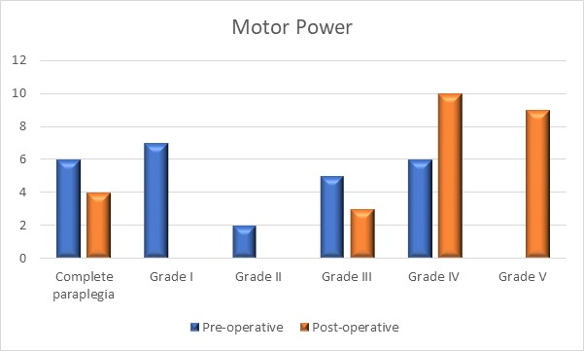
Fig 8. Preoperative muscle power state

In four cases iatrogenic dural tear was happened and repair was done simply. Three patients presented by CSF leak post-operative and stopped within 4 weeks after limitation of movement and medication. Superficial wound infection was noted in 4 cases which resolved with broad spectrum antibiotics and daily dressings (table 6).
Table 6. Postoperative complications in our series
Post-operative Complications | No. of patients | Percentage
Dural tear | 4 | 15.4%
Superficial wound infection | 4 | 15.4%
CSF leak | 3 | 11.5%
Pleural Injury | 0 | 0.0%
Vascular Injury | 0 | 0.0%
Neurological deterioration | 0 | 0.0%

Case (1)
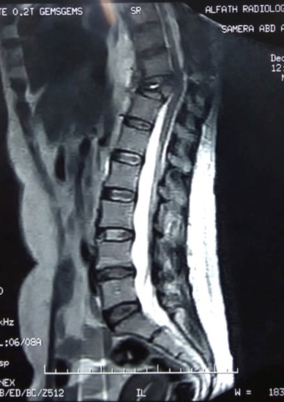 | 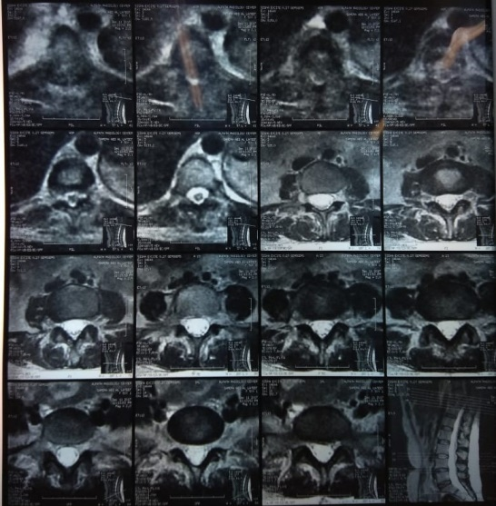
Fig 9. MRI dorsolumber spine show complete destruction of dorsal 11 in metastatic 47 years female with known history of breast cancer

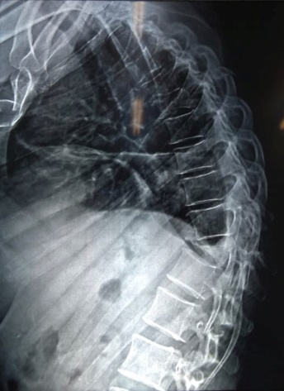 | 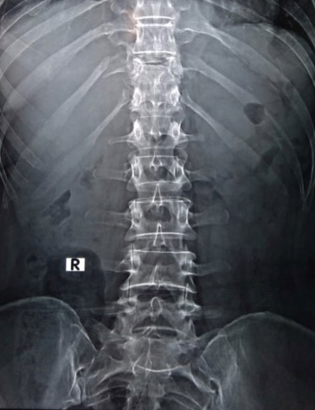
Fig 10. Preoperative imaging X-Ray spine AP and Lateral show complete destruction of Dorsal 11

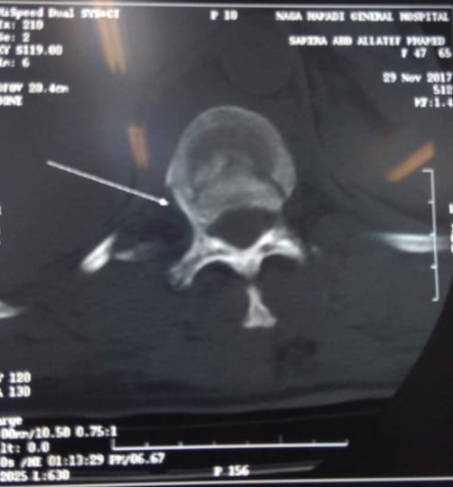 | 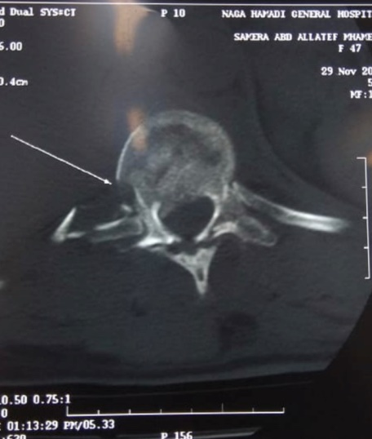
Fig 11. CT dorsal spine, axial cuts shows the osteolytic lesion and the destruction of dorsal 11

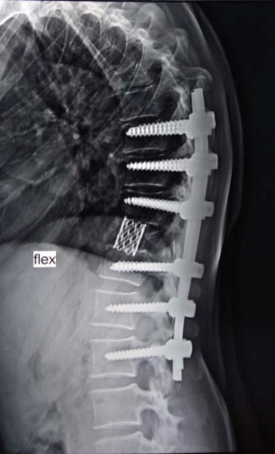 | 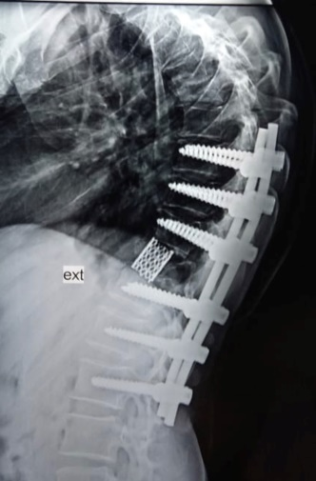
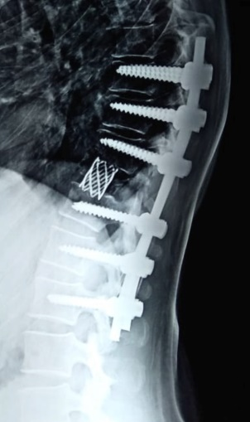 | 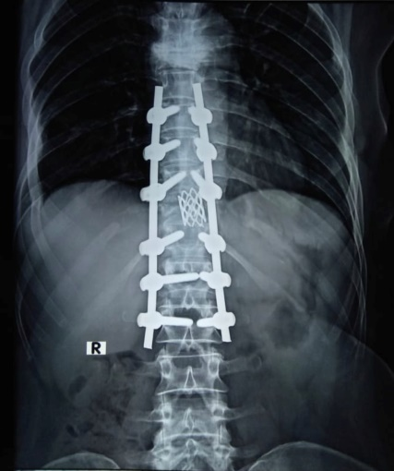
Fig 12. Six months post-operative X-ray follow up

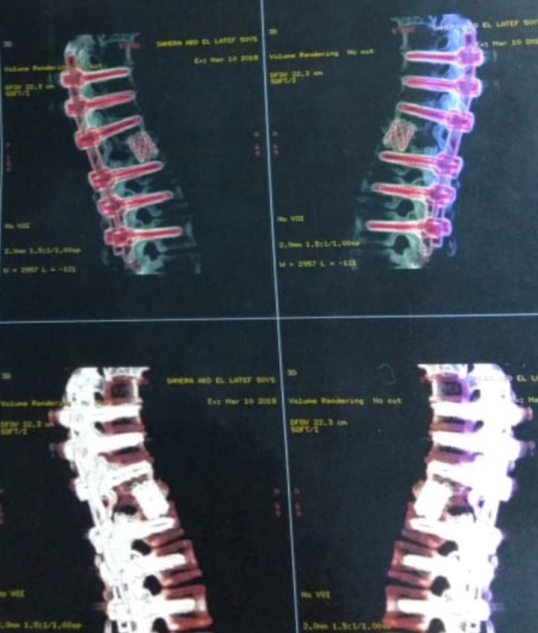
Fig 13. 3D CT follow up 6 months postoperative

Case (2)
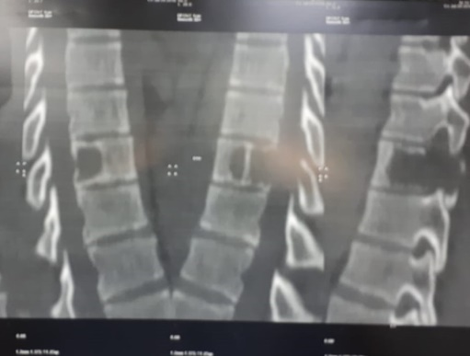 | 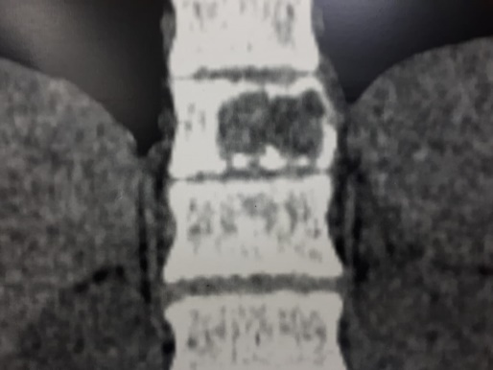
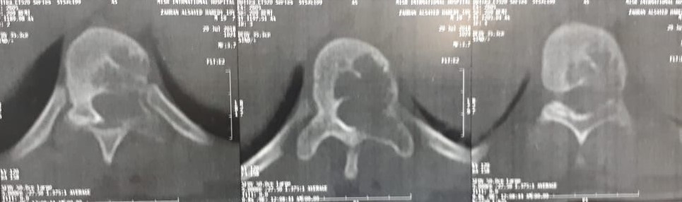
Fig 14. CT spine of 55 years male patient with metastatic lesion in dorsal 10 with a prostatic primary

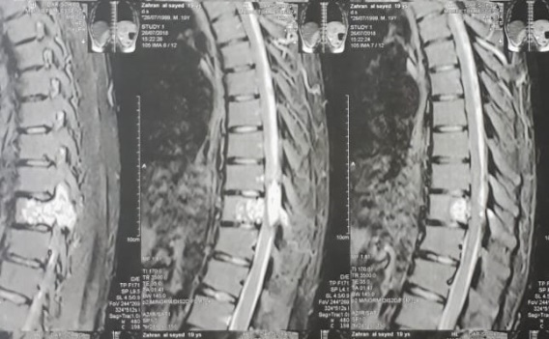 | 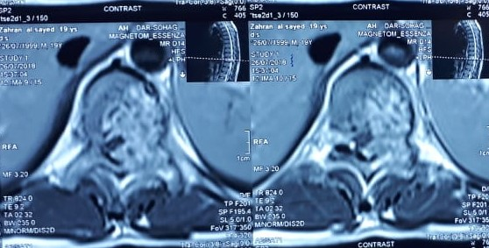
Fig 15. MRI dorsal spine showing the affection of Dorsal 10 in the same patient

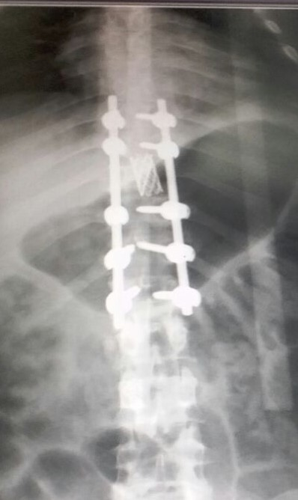 | 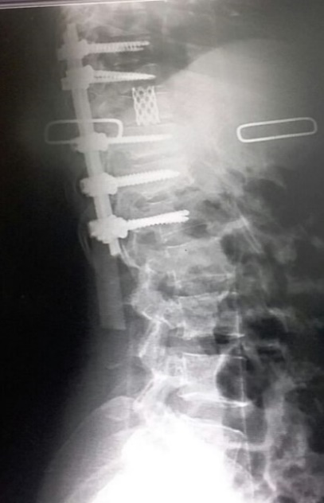
Fig 16. Post operative X-ray AP and Lateral after decompression with pyramesh cage reconstruction (case 2)
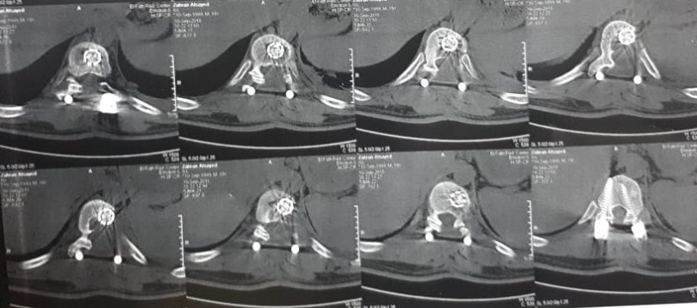
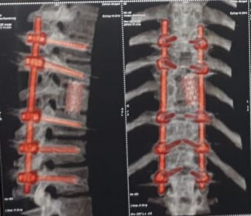
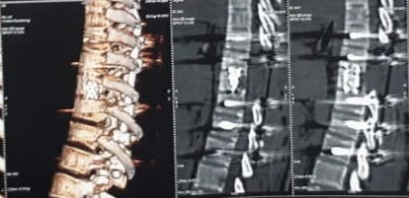
Fig 17. Three months follow up CT spine showing the transpedicular screws and the pyramesh (case 2)

Case (3)
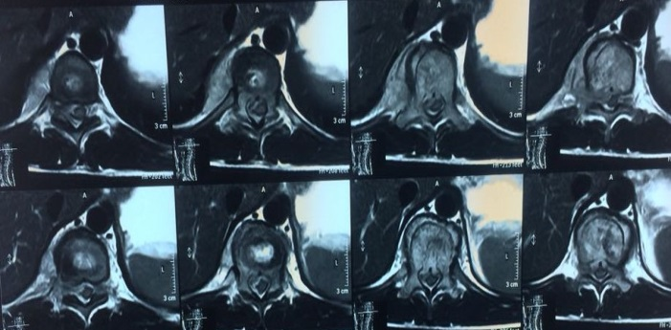
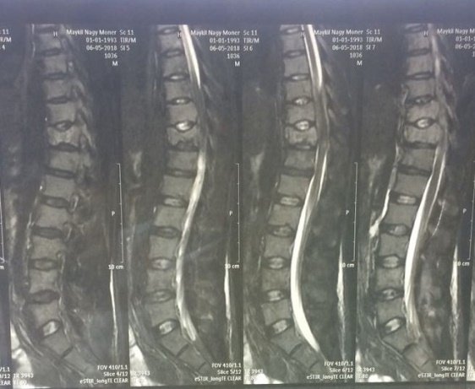
Fig 18. MRI dorsolumbar spine in 30 years male patient with history of retroperitoneal sarcoma shows dorsal 10-11 metastatic lesion
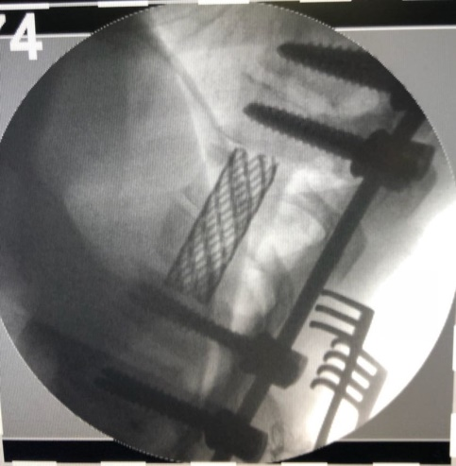
Fig 19. Intraoperative fluoroscopy showing the insertion of pyramesh cage with screws – rod system in case (3)
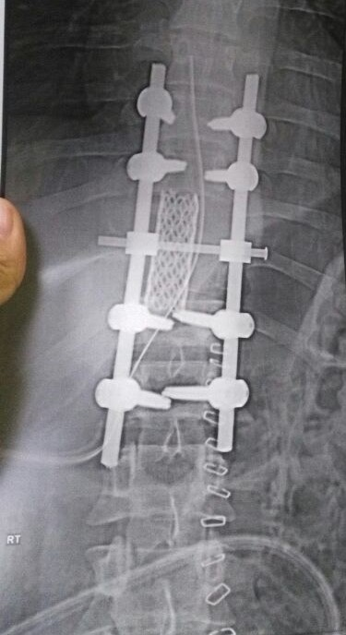 | 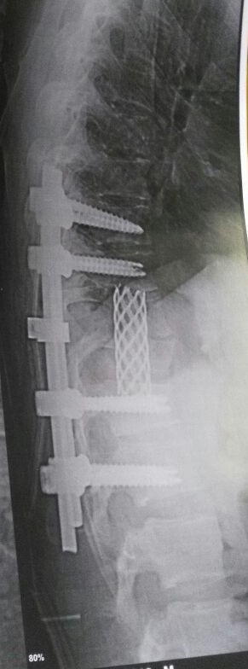
Fig 20. Post-operative X-ray spine AP and Lateral in the same patient case (3)

Discussion
Spinal metastasis is the most commonly encountered tumor of the spine^{,13} occurring in more than 40% of patients with cancer^{.11} Each year, 5% of patients with cancer will develop spinal metastasis. ¹⁹
Breast cancer comes to be the more frequent for causing spinal metastasis (21%) followed by lung cancer (14%). Dorsal spine is the commonest site for metastatic affection then lumber region and finally the cervical spine which is less frequent^{.11} Spinal metastasis can cause instability by destruction of the bony element or by pathological fracture which can occur under normal physiologic stress. ¹⁶
Partial or total destruction of the anterior vertebral body results in decreased load-bearing capacity of the spine and mostly resulted in spinal cord compression that need decompression, fixation and anterior reconstruction.^{4,13} Traditionally, these pathological conditions have been treated by a staged anterior and posterior decompression and fusion with a high risk for morbidity and mortality due to anterior approach in generally ill patients. ^{16,25}
In 1976 Larson and his colleagues described the lateral extracavitary approach^{.14} The difficulty of the spinal reconstruction due to unique anatomy of the lumbar spine with the association of increased blood loss and poor visualization across the midline has limited its widespread acceptance^{.(6,21,23)}
The extent of visualization is debatable and depends on the surgeon but with using the magnifying loops or microscope in most cases, a unilateral approach may be performed safely to the contralateral pedicle with good visualization. A bilateral approach is appropriate in situations of primary malignancy or solitary metastatic disease where an en bloc spondylectomy is advisable. Blood loss can be minimized by skeletonizing the pedicle with resection of the transverse process putting gelfom and surgicell in the lateral border of the vertebral body also leaving the ventral cortex provide to us a safe zone from epidural veins bleedings^{.9}
Still sacrificing with the nerve root intraoperative in lumbar region is a common surgical choice for placing the pyramesh but we can avoid this by gently placing the root caudly then we enter with the pyramesh parallel to the root the rotate it inside the corpectomy hole. In dorsal lesions we can sacrifice the root by ligation and bipolar diathermy. Recently with the advent of expandable metallic cages all-posterior spinal reconstruction can be accomplished without sacrificing the lumbar spinal nerve roots. Hunt and colleagues described the use of an expandable cage in a single patient^{.6}
Leaving the ventral cortex after drilling the vertebral body provides for us the advance to keep both the spinal cord and the epidural veins away from intraoperative iatrogenic injury. Also the slow dissection through the lateral border of the vertebral body by the packing sponge protects the intrabdominal vascular injury in lumber spine or the pleural injury in the dorsal spine.²²
Most authors agreed for transpedicular fixation of two levels above and two levels below the affected segment but we can modulate this according to the quality of bone and in there is abnormalities along the spine in another segment. ⁹ In our study we found a case with wedged vertebrae above the affected segment and this make us to lengthen the fixation segment.
Reduction in the operative time and avoidance of staged surgery with its morbidity and surgical blood loss give the advance to posterolateral approach. So a single-staged, lumbar extracavitary corpectomy and circumferential reconstruction should be a part of every spine surgeon’s armamentarium.
Conclusion:
Posterolateral corpectomy and reconstruction approach in the management of metastatic dorsolumber spine lesions with destruction of the vertebral body are effective and safe surgical approach with less time and minimal blood. All patients improved in back pain while most of them improved regarding the neurological deficit. A larger study advised for more evaluation and exposing complications.
Acknowledgment:
I would like to thank all patients participated in this study.
Funding: None
Disclosure: No conflict of interests among authors

References
- Bhardwaj P, Bhardwaj N. Motor grading of elbow flexion - is Medical Research Council grading good enough? J Brachial Plex Peripher Nerve Inj 13;4:3. 2009.
- Bianchi C, Ballard JL, Abou-Zamzam AM, Teruya TH, Abu-Assal ML. Anterior retroperitoneal lumbosacral spine exposure: operative technique and results. Ann Vasc Surg. 17(2):137-142, 2003.
- Boland PJ, Lane JM, Sundaresan N. Metastatic disease of the spine. Clin Orthop Relat Res169:95-102, 1982.
- Dimar JR, Voor MJ, Zhang YM, Glassman SD. A human cadaver modelfor determination of pathologic fracture threshold resulting from tumorous destruction of the vertebral body. Spine 23:1209–14, 1998.
- Harrington KD. Metastatic disease of the spine. J Bone Joint Surg Am. 68:1110-1115, 1986.
- Hunt T, Shen FH, Arlet V. Expandable cage placement via a posterolateral approach in lumbar spine reconstructions. Technical note. J Neurosurg Spine (Phila Pa 1976). 5(3):271-274. 2006.
- Jacobs WB, Perrin RG. Evaluation and treatment of spinal metastases: an overview. Neurosurg Focus. December 11(article 1):1-11, 2001.
- Kanayama M, Ng JT, Cunningham BW, Abumi K, Kaneda K, McAfee PC. Biomechanical analysis of anterior versus circumferential spinal reconstruction for various anatomic stages of tumor lesions. Spine (Phila Pa 1976); 24(5):445-450, 1999.
- Kern Singh, and Daniel K. Park. Lumbar Extracavitary Corpectomy with a Single Stage Circumferential Arthrodesis: Surgical Technique and Clinical Series. The American Journal of Orthopedics 7(2):316-320, July 2012.
- Klimo P Jr, Dailey AT, Fessler RG. Posterior surgical approaches and outcomes in metastatic spine disease. Neurosurg Clin N Am. 15(4):425435, 2004.
- Klimo P Jr, Schmidt MH. Surgical management of spinal metastases. Oncologist 9:188–96 3, 2004.
- Kopec JA, Esdaile JM, Abrahamowicz M, Abenhaim L, Wood-Dauphinee S, Lamping DL, etal, The Quebec Back Pain Disability Scale. Measurement properties. Spine 20(3):341-52, 1995.
- Krishnaney AA, Steinmetz MP, Benzel EC. Biomechanics of metastatic spine cancer. Neurosurg Clin N Am 15:375–80, 2004.
- Larson SJ, Holst RA, Hemmy DC, Sances A Jr. Lateral extracavitary approach to traumatic lesions of the thoracic and lumbar spine. J Neurosurg. 45(6):628-637, 1976.
- Lubicky JP, Patel NS, DeWald RL. Two-stage spondylectomy for giant cell tumor of L4. A case report. Spine (Phila Pa 1976). 8(1):112-115, 1983.
- National Cancer Institute. Bethesda, Md, Available at: http://seer. cancer.gov/csr/1975_2005/, based on November 2007 SEER data submission. Accessed August 7, 2007.
- Oda I, Cunningham BW, Abumi K, Kaneda K, McAfee PC. The stability of reconstruction methods after thoracolumbar total spondylectomy. An in vitro investigation. Spine 24(16):1634-1638, 1999.
- Resnick DK, Benzel EC. Lateral extracavitary approach for thoracic and thoracolumbar spine trauma: operative complications. Neurosurgery. 43(4):796-802; 1998.
- Ries LAG, Melbert D, Krapcho M, eds. SEER Cancer Statistics Review, 1975–2005.
- Sakaura H, Hosono N, Mukai Y, Ishii T, Yonenobu K, Yoshikawa H. Outcome of total en bloc spondylectomy for solitary metastasis of the thoracolumbar spine. J Spinal Disord Tech. 17(4):297-300, 2004.
- Samartzis D, Foster WC, Padgett D, Shen FH. Giant cell tumor of the lumbar spine: operative management via spondylectomy and shortsegment, 3-column reconstruction with pedicle recreation. Surg Neurol. 69(2):138-141, 2008.
- Schmidt MH, Larson SJ, Maiman DJ. The lateral extracavitary approach to the thoracic and lumbar spine. Neurosurg Clin N Am15 (4):437-441, 2004.
- Senel A, Kaya AH, Kuruoglu E, Celik F. Circumferential stabilization with ghost screwing after posterior resection of spinal metastases via transpedicular route. Neurosurg Rev. 30(2):131-137; 2007.
- Snell BE, Nasr FF, Wolfla CE. Single-stage thoracolumbar vertebrectomy with circumferential reconstruction and arthrodesis: surgical technique and results in 15 patients. Neurosurgery. 58(4 Suppl 2): ONS-263-268; 2006.
- Windhagen HJ, Hipp JA, Silva MJ, Lipson SJ, Hayes WC . Predicting failure of thoracic vertebrae with simulated and actual metastatic defects. Clin Orthop Relat Res313–19, 1997.
- Wong DA, Fornasier VL, MacNab I. Spinal metastases: the obvious, the occult, and the impostors. Spine. 15:1-4, 1990.

الملخص العربي
استئصال الفقرات من الخلف واستخدام شبكة بيرا في اعادة بناء الفقرات في حالات الاورام الثانوية في الفقرات الصدرية والقطنية
مقدمة البحث
يعتبر العمود الفقارى من اكثر الاماكن العظمية فى الجسم عرضة للاصابة بثانويات الاورام وتمثل الفقرات الظهرية الاكثر شيوعا فى الاصابة وتليها الفقرات القطنية.
معظم هذه الاصابات تمثل ضغط شديد على الحبل الشوكى وهذه الحالات تحتاج الى تدخل جراحى لازالة الضغط مع تثبيت الفقرات من الخلف واعادة هيكلة الفقرة المصابة.يغتبر التدخل الخلفى الجانبى لاتمام هذه الجراحات مع تركيب شبكة من التيتانيوم بديلة للفقرة الاكثر امانا من التدخلات الجراحية الاخرى والتى تحتاج الى التدخل الجراحى من الامام والخلف.
الغرض من البحث
دراسة فعالية هذا الاجراء من حيث تقليل درجة الالم وتحسين القدرة الحركية لدى هؤلاء المرضى.
تصميم البحث
دراسة مرجعية قامت في مستشفى سوهاج الجامعي خلال ثلاث سنوات ما بين أغسطس 2014 وأغسطس 2017 وتشمل المرضى المصابون بأورام ثانوية في الفقرات الصدريةوالقطنية.
طريقة البحث
تمت هذه الدراسة على عدد 26 مريض أغلبهم من الرجال بنسبة69.2% مصابون بثانويات بالفقرات الصدرية والقطنية وتم التدخل الجراحى الخلفى الجانبى مع تثبيت الفقرات وتركيب شبكة من التيتانيوم بديلا للفقرة المصابة وتمت متابعة المرضى ما بعد التدخل الجراحى ما بين 6-12 شهر.
نتيجة البحث
كان أغلبية المرضى من الذكور (18 مريضا) وكان المدى العمري للمرضى ما بين 33 و67 عاما . كل المرضى تحسنوا في درجة الالم. أربعة مرضى عانوا من عدوى سطحية بالجرح وتم علاجها بالغيارات المتكررة عالجرح مع استعمال المضادات الحيوية واسعة المدى واربعة مرضى عانوا من قطع في الام الجافية أثناء اجراء العملية. أكثر من 80% من المرضى تحسنوا في القدرة الحركية بعد العملية. أربعة مرضى فقط لم يتم تحسنهم لان حالتهم المبدئية كانت سيئة.
ملخص البحث
التدخل الخلفي الجانبي كعلاج أحادي يعد طريقة فعالة وءامنة لدى مرضى الاورام الثانوية بالفقرات فيما يخص درجة تحسين الالم والقدرة الحركية لهؤلاء المرضى.

